SESSION 13
SIMPLE MOVING AVERAGE

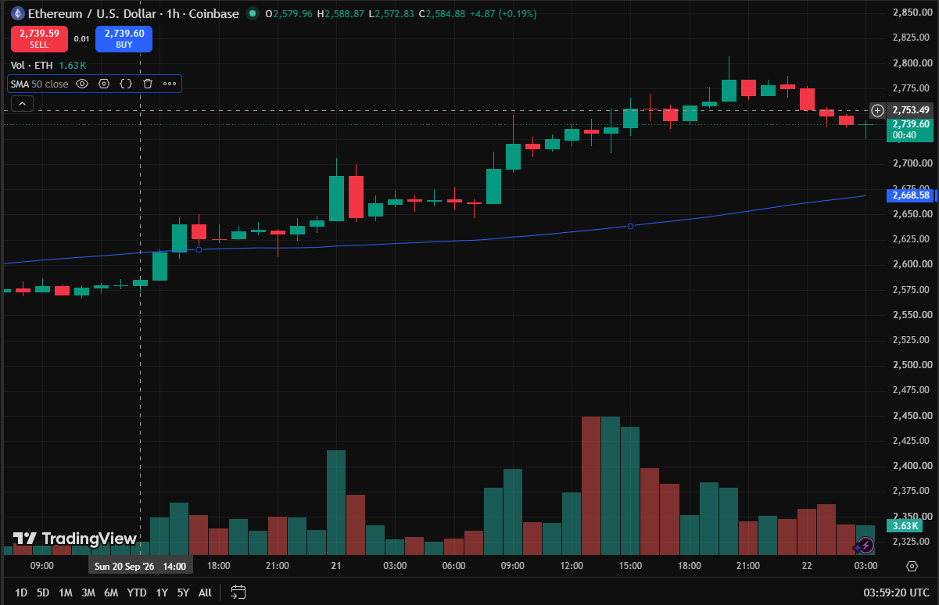

SESSION 14
RELATIVE STRENGTH INDEX

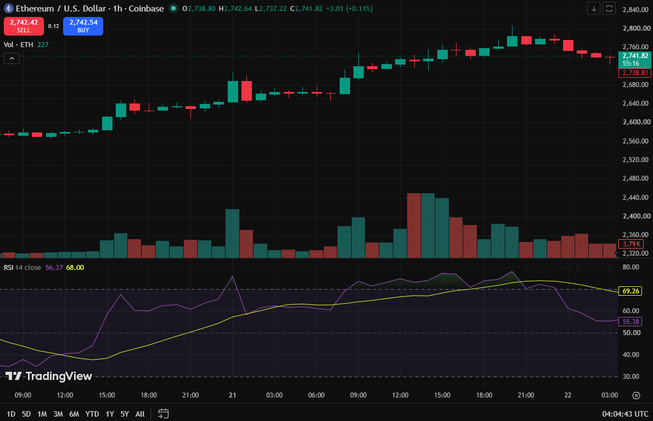

The Rise is 69.26, it is neutral so we can hold.

SESSION 15
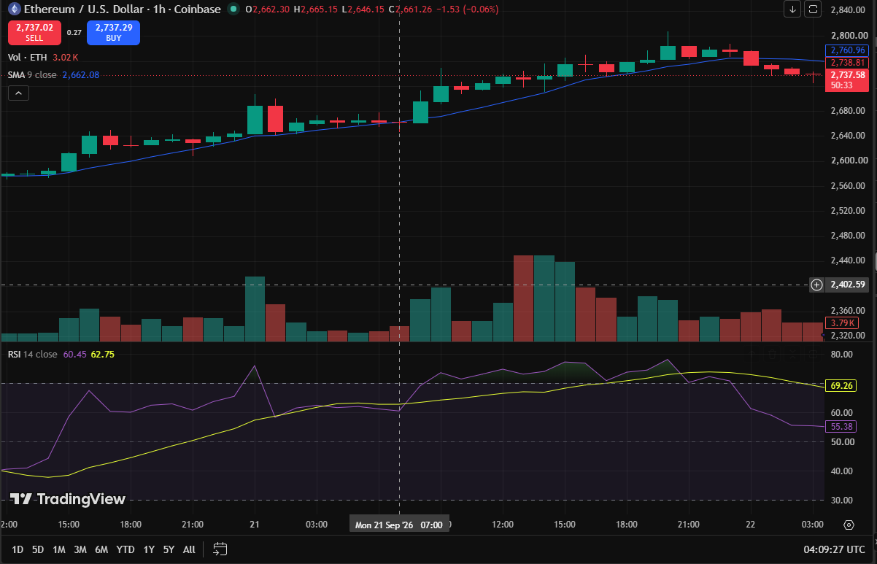

Indicator Based Trading Report

Market Observation

Particulars | Observation
Asset | ETHUSD
Timeframe | 1 hour
Price Position | Above 50 SMA
SMA Direction | Upward
Current RSI | 55.38
RSI Zone | Neutral (30-70)

Trading Decision

Particulars | Observation
Trade Executed | Yes
Trade Type | Long (Buy)
Reason | Trade Entry Rationale: The long trade was executed because ETHUSD was in an upward trend above its ascending moving average with an RSI of 55.38 holding in bullish territory above 50.  Why it Failed: The entry bought the peak of an overextended move just as RSI momentum was actively declining from overbought levels (>70), resulting in an immediate mean-reversion pullback toward dynamic moving average support.

Trade Details

Particulars | Observation
Entry Price | 2738.29
Exit Price | 2671.42
Realized Profit/Loss | -6.69USD
Trade Outcome | loss

